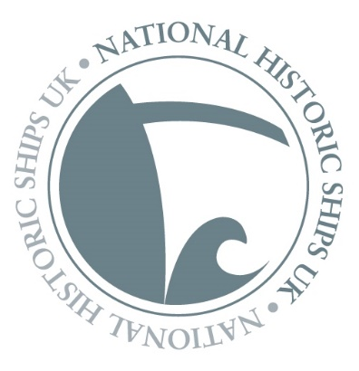

National Historic Ships UK Vessel Owners’ Survey 2020

Fill in our survey for a chance to win

Fill in our survey and you will be entered into a draw to win the fantastic prize* of a 2-5 day short course, donated by our sponsor the Boat Building Academy in Lyme Regis, and worth up to £750!
This survey applies to all craft listed on the Registers. It is being undertaken by NHS-UK as part of its regular update procedure, but also to gather additional information ahead of a full review of the Historic Ship Registers. We encourage all owners to participate in this survey, which should take approximately 15 minutes to complete.
The Registers are a vital tool for historical research purposes, funding and conservation priorities, as well as policy work, and we need your help to make sure the information they hold is as up to date and accurate as possible!

Thank you for your help in completing this survey. If you have any queries, please email us at info@nationalhistoricships.org.uk

* Prize is for a 2 or 5 day short course at the Boat Building Academy in Lyme Regis. Any short course can be chosen up to the value of £750, subject to availability. The BBA's 2020 Short Course programme can be viewed on their website www.boatbuildingacademy.com. The course must be taken by the end of 2021, and no alternative cash prize can be offered.

National Historic Ships UK Vessel Owners’ Survey 2020

Questions 1 – 15 (for ALL vessel owners)

1, Name of vessel:

2, NRHV / NAHV Certificate Number:

3, Is your vessel up for sale Y/N? If yes, please provide details:

4, Current location of vessel (Place name, County):

5, Vessel’s current use (please mark ONE answer only):

- Commercial activity
- Community vessel
- Private use
- Museum based
- Ongoing conservation
- Sail
- Unknown
- Other (please specify below)

6, Your name:

7, Address:

8, Mobile number:

9, Email address:

10, Vessel website address:

11, Did the build and design of your vessel feature any technical innovations or advances in construction methods? If yes, please briefly describe these.

12, Name of vessel designer (if known):

13, Vessel history (please supply any additional information NOT already listed in the vessel Register entry, including associations with people, places or events):

Search the Registers to check what information is already published on your vessel on our website: www.nationalhistoricships.org.uk/the-registers/find-a-vessel

14, Please briefly describe any conservation work carried out on your vessel, the approach taken, and level of surviving material:

15, Is your vessel intended for / or currently in:

- Static Preservation
- Operational use

If you answered a) Static Preservation, please now ONLY answer questions 16-18.

If you answered b) Operational use, please now ONLY answer questions 19-24.

Questions 16-18 (for vessels undergoing Static Preservation ONLY)

16, Would you describe your vessel as:

- Stabilised pending conservation
- Undergoing conservation work
- Post-conservation
- At risk

Please explain why you gave this answer:

17, What monitoring processes do you have in place for your vessel?

18, Do you have a conservation management plan in place for your vessel?

- Yes
- No

Thank you for taking the NHS-UK Vessel Owners’ Survey!

Please return your completed form to info@nationalhistoricships.org.uk

Questions 19 – 24 (For vessels in Operational use ONLY)

19, Describe any significant works or changes to your vessel which have impacted on original material (including to the hull, rig, deck, engine and accommodation):

20, have any replacement materials been like-for-like and / or included replica parts? Please describe:

21, Describe any adaptations made to your vessel for operational use, including to comply with MCA or other regulations:

22, Do you have a written maintenance plan in place for your vessel?

- Yes
- No

23, How would you describe your vessel? (Circle or mark ONE answer only)

- In need of significant repairs

- Operational, with a few localised problems

- In good operational condition and subject to regular maintenance

- In excellent operational condition with long term maintenance plan in place

24, Please explain why you gave this answer:

Thank you for taking the NHS-UK Vessel Owners’ Survey!

Please return your completed form to info@nationalhistoricships.org.uk

